Smart Home Project

Project Done by:   
**Karim Hisham Mohamed   
Group C42**

*Date: 13/12/2020*

# Abstract

Smart Homes, also known as automated homes, smart buildings, integrated home systems or home automation, are recent developments in design. Intelligent homes incorporate common devices that control the home's features. Smart home technology was originally used to control environmental systems such as lighting and heating, but recently the use of smart technology has developed so that the system can include almost any electrical component in the house. The result of these technology changes is that a smart home can now monitor the activities of the home occupant, operate devices independently in predefined patterns or independently, as required by the user.

This project is a smart home project, Bluetooth based, meaning that it can be controlled using a smart phone via Bluetooth. The objective is to control a lamp in a room, Garage gate (DC Motor) and a temperature sensor display with an alarm lamp.

Contents

Abstract 2

Introduction 4

Principle of working 5

Proteus simulation 6

# Introduction

The idea of the project is that a data is sent from the Bluetooth module to MCU1 through USART communication protocol, and then the same data is sent from MCU1 to MCU 2 through SPI communication protocol. Lastly MCU2 collects the data and then controls the devices based on the data being sent.

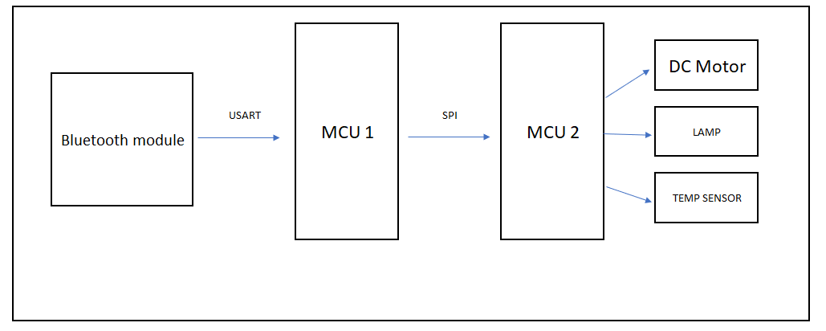

# Principle of working

The data being sent to MCU1 contains characters. Each character has its own function. Moreover, MCU1 passes the data to MCU2. MCU2 code includes conditions based on the data (character) being sent. These commands are to control motor and lamp and to monitor temperature room. The temperature is monitored and shown on lcd. An alarm lamp will turn on if the temperature exceeded 60 Celsius.

Motor Control

f ==> Motor Forward

s ==> Motor Stop

r ==> Motor Reverse

Lamp Control

l ==> Lamp On

d ==> Lamp Off

Temp Monitor

t ==> Room Temperature

# Proteus simulation

